Variable and Datatype in Java

**Variable** is a name of memory location. There are three types of variables: local, instance and static. There are two types of datatypes in java, primitive and non-primitive.

**Variable**

Variable is name of reserved area allocated in memory.

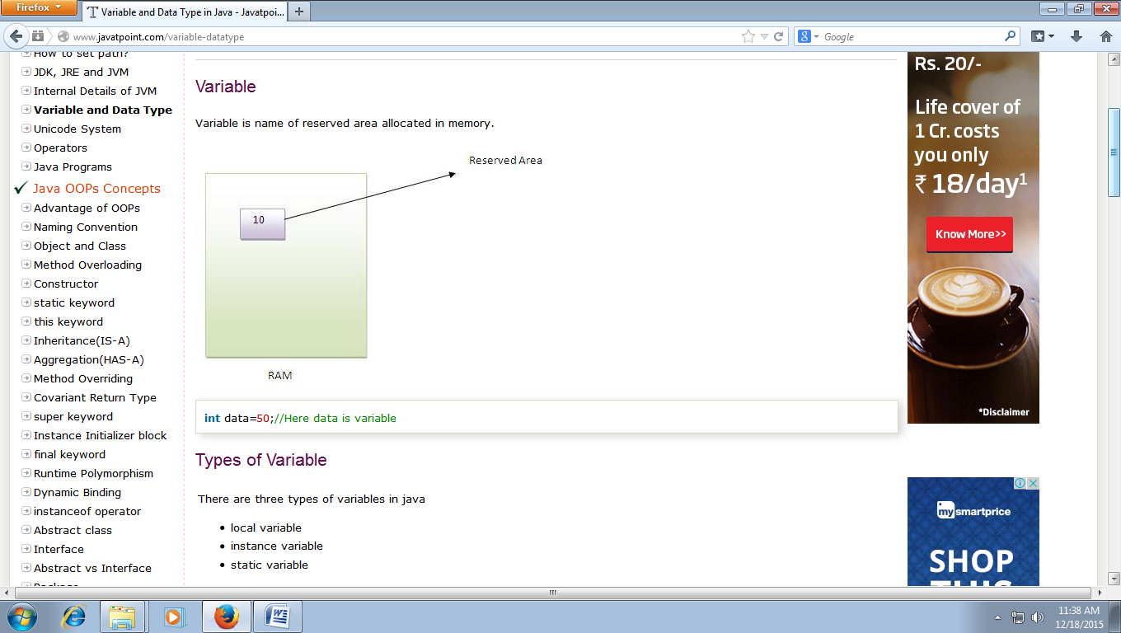

**Types of Variable**

There are three types of variables in java

* local variable
* instance variable
* static variable

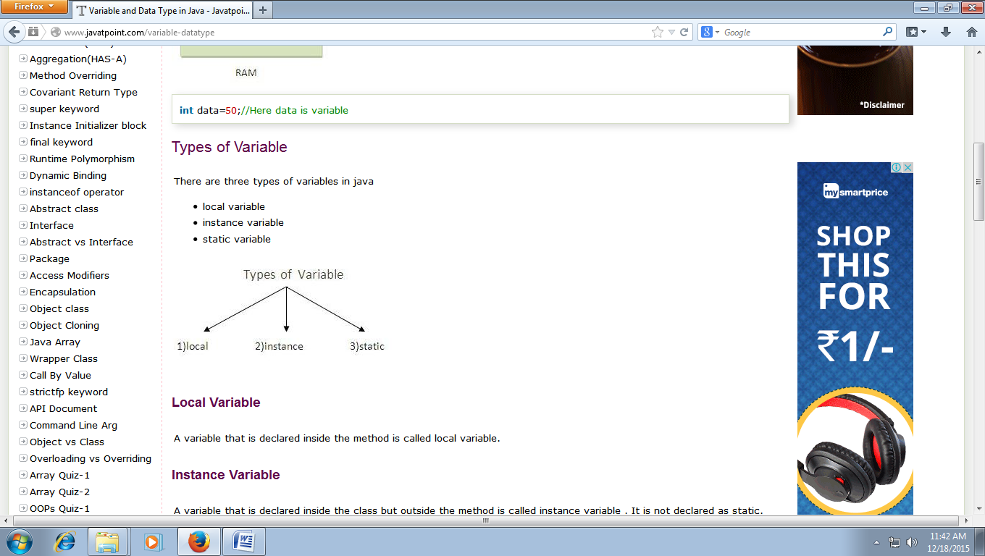

**Local Variable**

A variable that is declared inside the method is called local variable.

**Instance Variable**

A variable that is declared inside the class but outside the method is called instance variable . It is not declared as static.

**Static variable**

A variable that is declared as static is called static variable. It cannot be local.

class A{

int data=50;//instance variable

static int m=100;//static variable

void method(){

int n=90;//local variable

}

**Data Types in Java**

In java, there are two types of data types

1) primitive data types

2) non-primitive data types

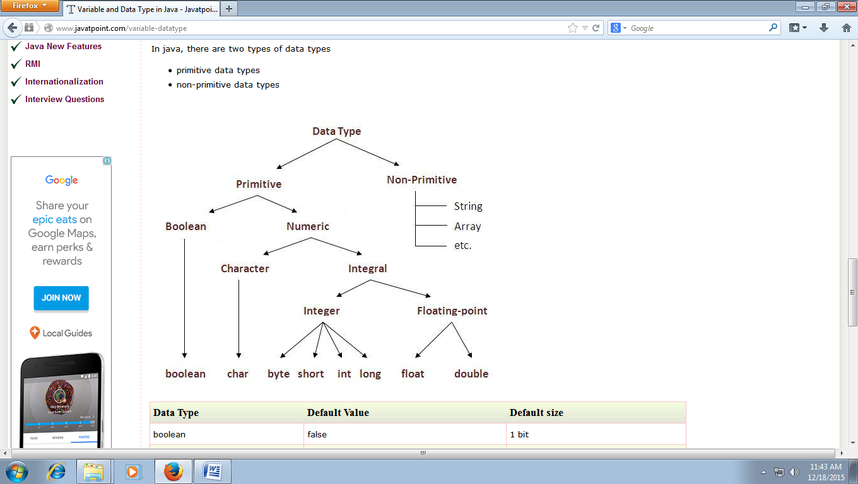

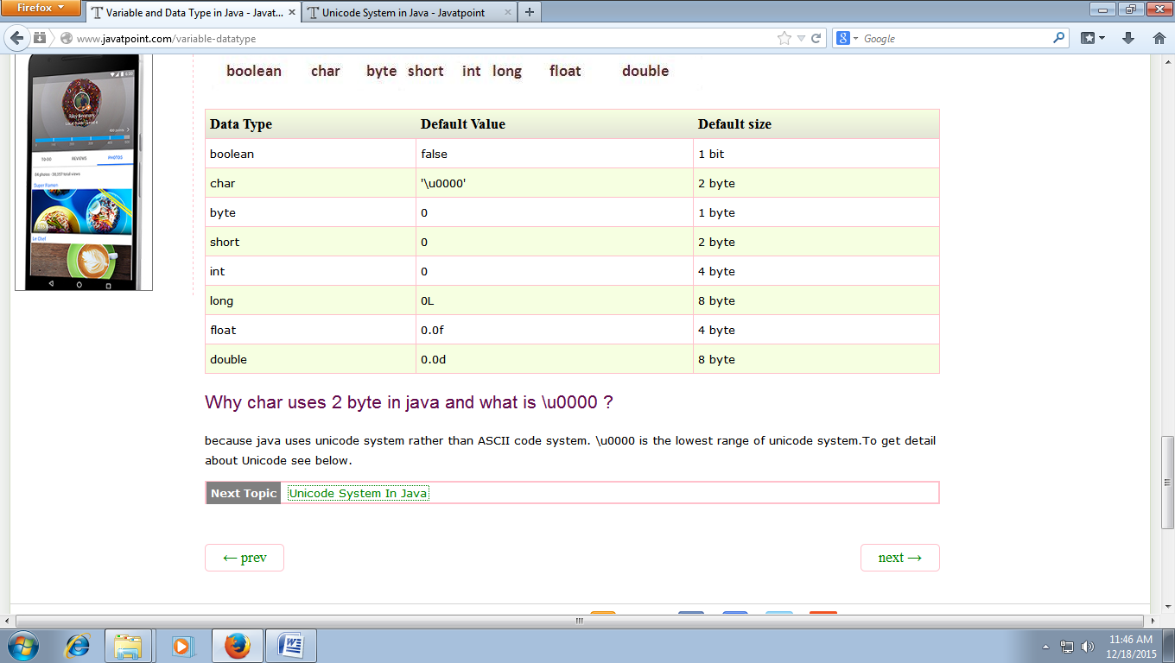

**Operators in java**

Operator in java is a symbol that is used to perform operations. There are many types of operators in java such as unary operator, arithmetic operator, relational operator, shift operator, bitwise operator, ternary operator and assignment operator.

